**Deliverable 3**

**Software quality engineering**

**Group Members:**

• Zainab Asim (21L-5822)

• Ali Hamza (21i-1107)

• Minahil Numan (21L-6126)

• Ahmed Jalil (21L-5813)

• Dua Mohyyuddin (21L-5797)

**User login**

|  |  |  |  |
| --- | --- | --- | --- |
| **Bug** | **Description** | **Priority** | **Severity** |
| Username and password | Invalid username and invalid password  If we enter invalid username or password it does not show an error messages | Low | low |

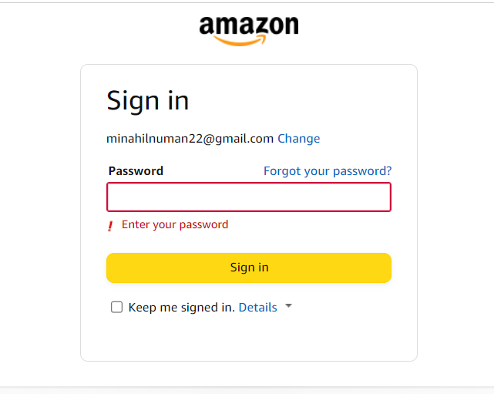

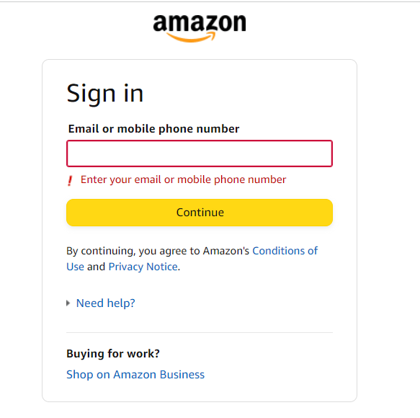

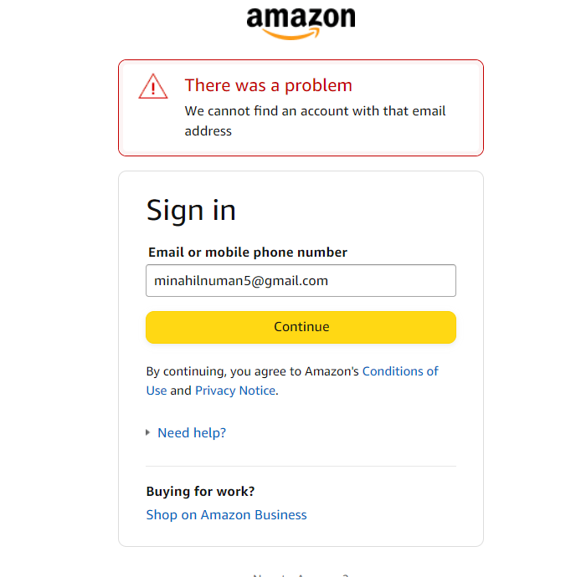

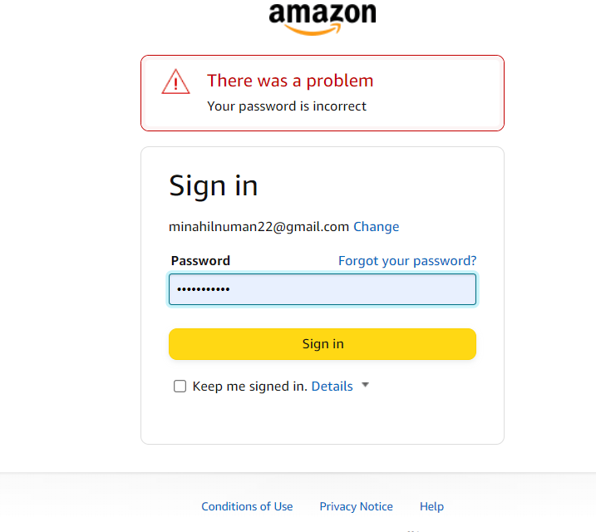

**Register**

|  |  |  |  |
| --- | --- | --- | --- |
| **bugs** | **Description** | **Priority** | **Severity** |
| Invalid username  And password and  email | Username, password, and email (not unique)  Password has no definite range.  Username accepting spaces and special character | low | low |

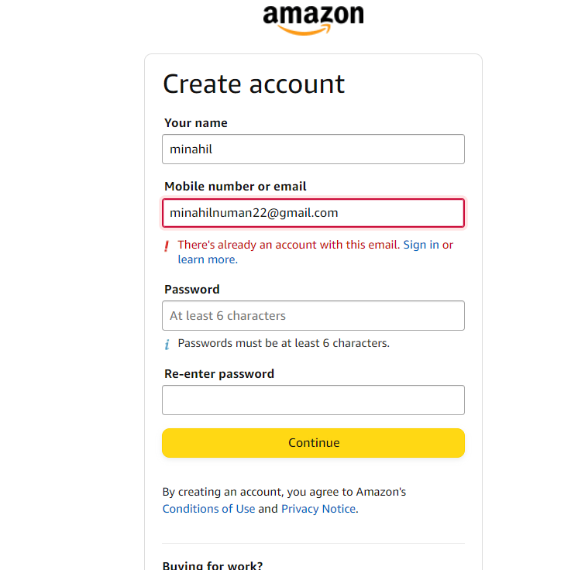

2.

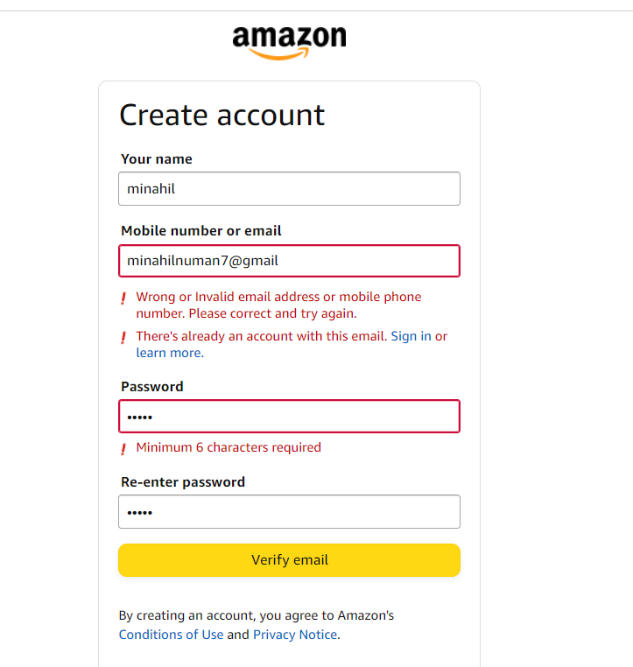

Admin login

|  |  |  |  |
| --- | --- | --- | --- |
| **Bugs** | **description** | **Priority** | **Severity** |
| Username and password | Invalid username and password redirecting to error page | low | low |

Admin dashboard

|  |  |  |  |
| --- | --- | --- | --- |
| **Bugs** | **Description** | **Priority** | **Severity** |
| Homepage  And logout | By clicking the homepage it redirects to an error page  By clicking logout it redirects to the user's login | high | high |

Category

|  |  |  |  |
| --- | --- | --- | --- |
| **Bugs** | **Description** | **Priority** | **Severity** |
| Add item | Do not display a message after adding the product | low | low |
| update | If we give empty space it will still update the category | medium | medium |
| delete | Not working | medium | medium |

Product

|  |  |  |  |
| --- | --- | --- | --- |
| **Bugs** | **Description** | **Priority** | **Severity** |
| Add product | if we leave some filled it will redirect to an error page | high | high |
| update | Redirect to error page | high | high |

https://breakout.com.pk/collections/women-jewellery

**Customer**

|  |  |  |  |
| --- | --- | --- | --- |
| **Bugs** | **Description** | **Priority** | **Severity** |
| Crud operation | Crud operations are not working | high | high |

**User**

|  |  |  |  |
| --- | --- | --- | --- |
| **Bugs** | **Description** | **Priority** | **Severity** |
| logout | User cannot logout as this button is not working | low | low |
| cart | Not working | high | high |
| profile | Not working | medium | medium |
| Add to cart | Not working | high | high |

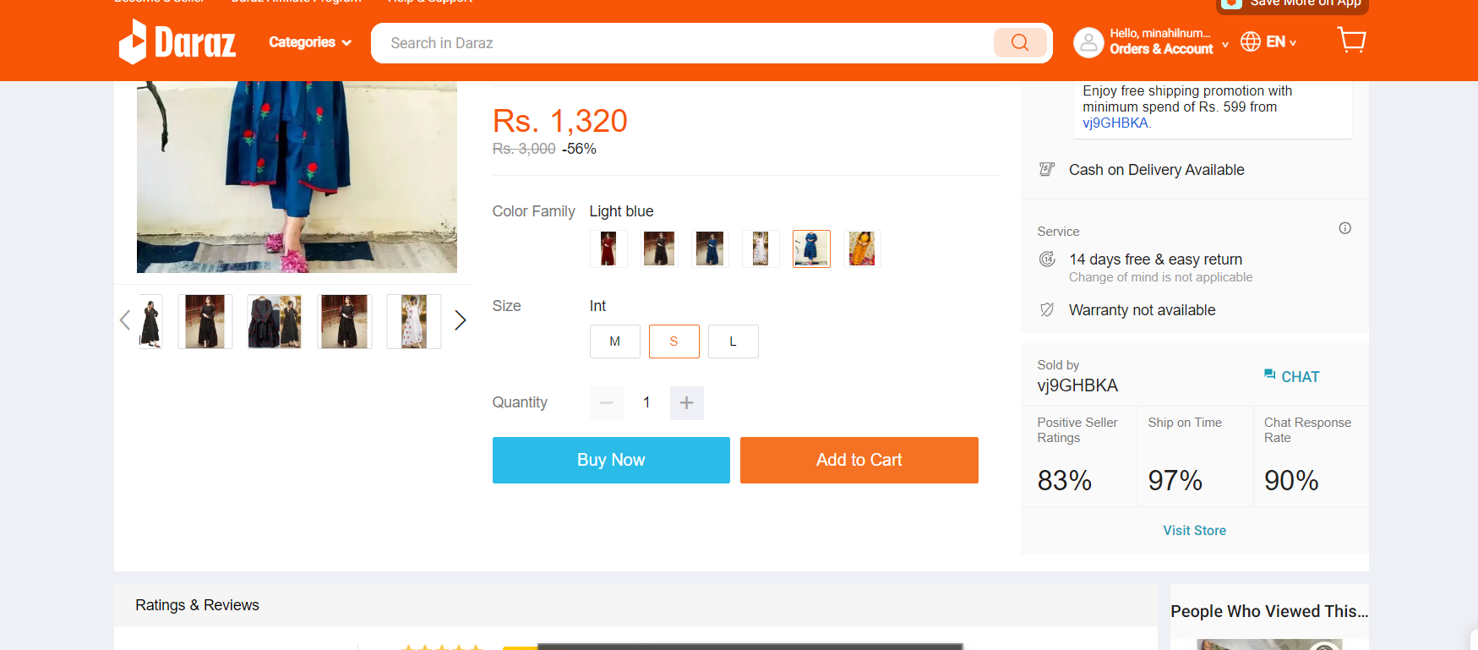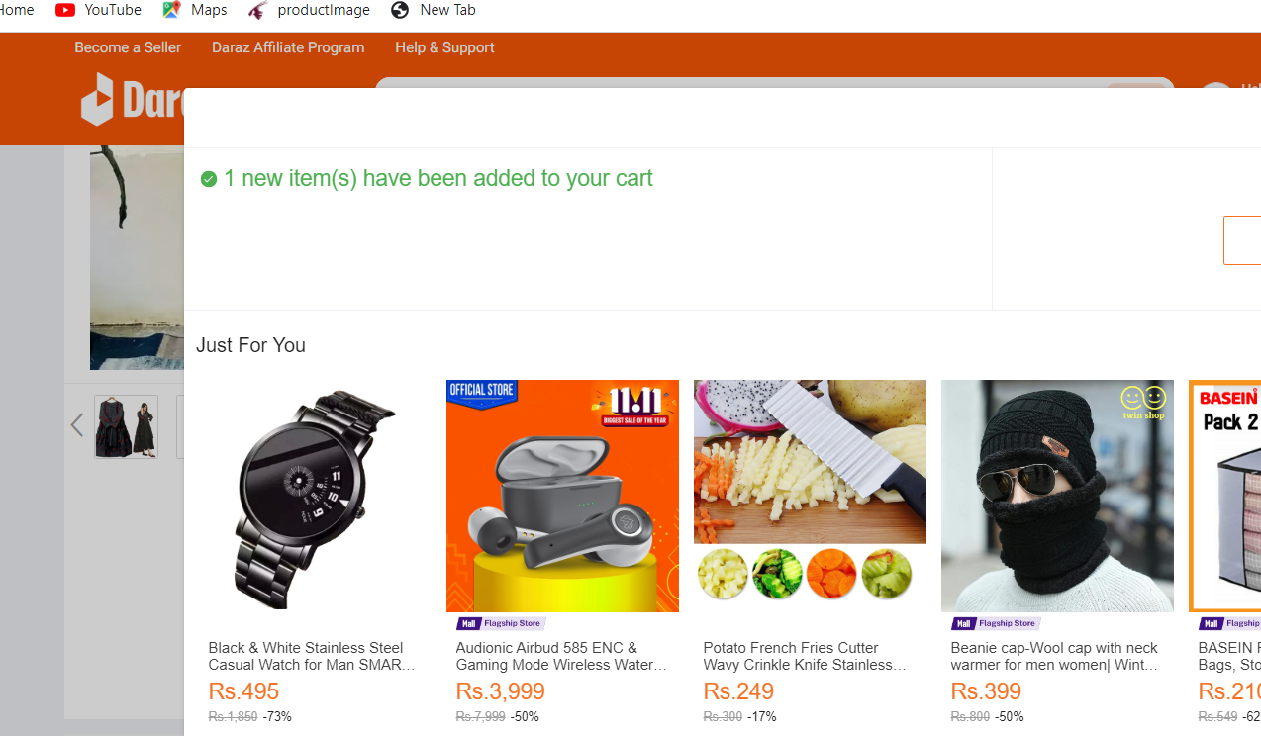

Cart

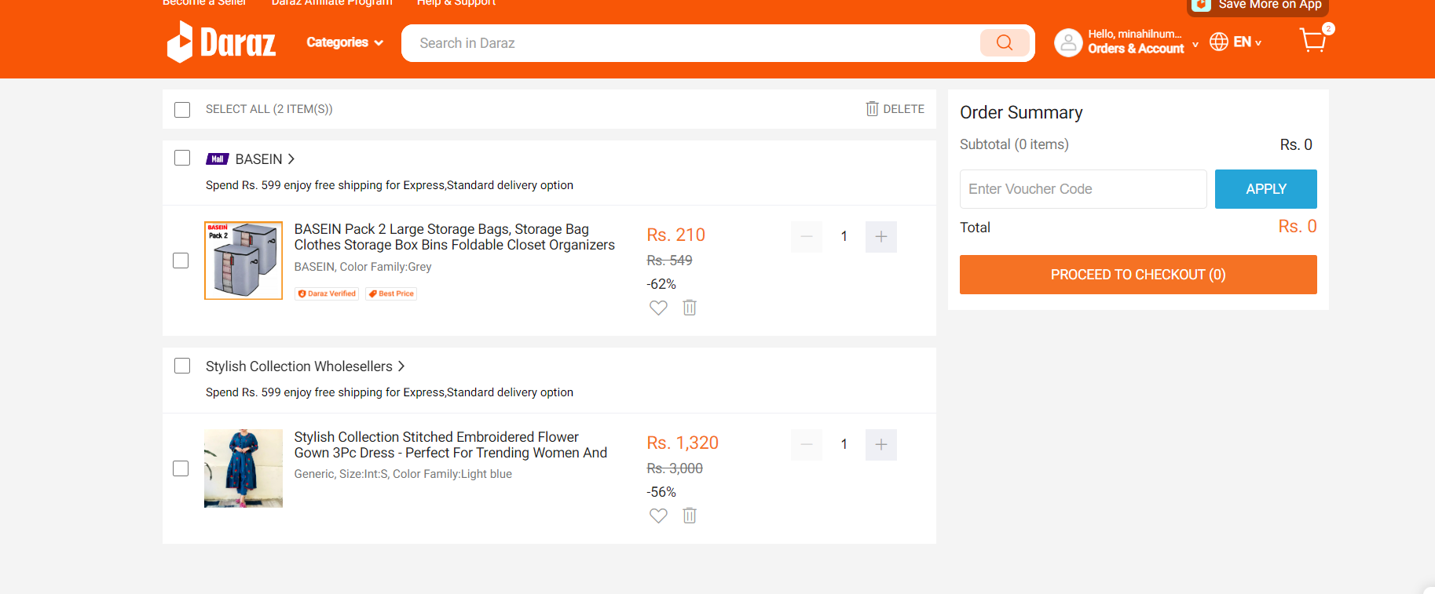

Logout

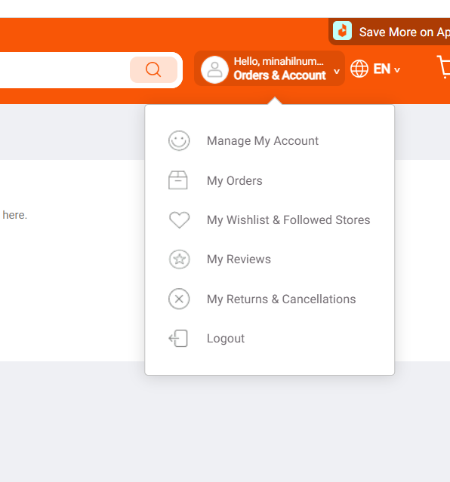

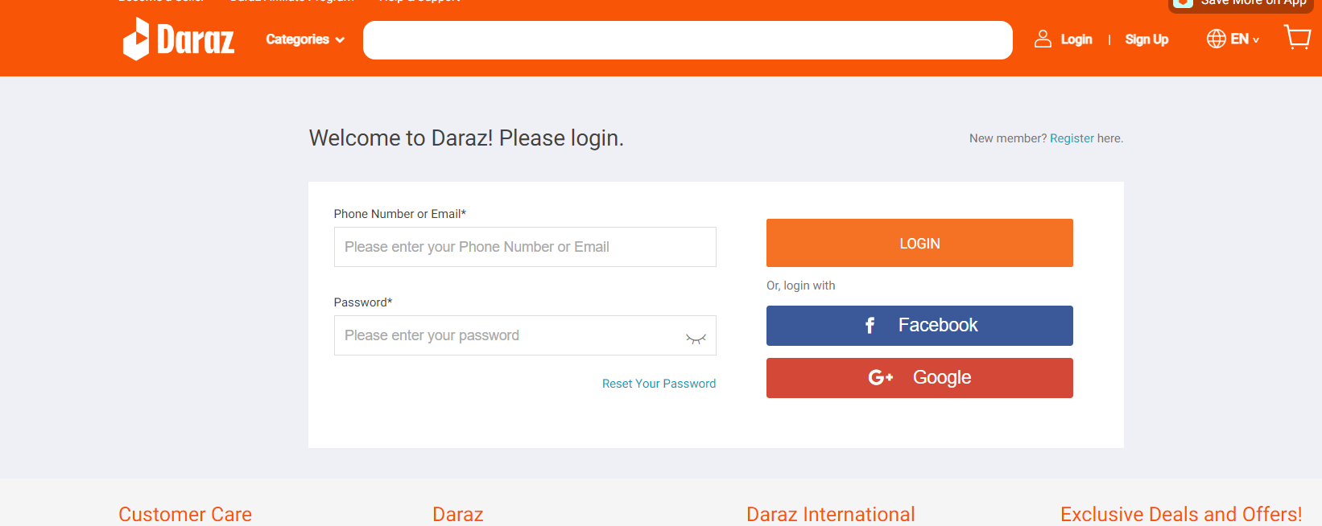

**Missing features**

|  |  |  |
| --- | --- | --- |
|  | **Priority** | **Severity** |
| 1 | low | low |
| 2 | high | high |
| 3 | medium | medium |
| 4 | medium | medium |
| 5 | high | high |
| 6 | medium | medium |

